LOOK FOR INFORMATION October 27, 2020

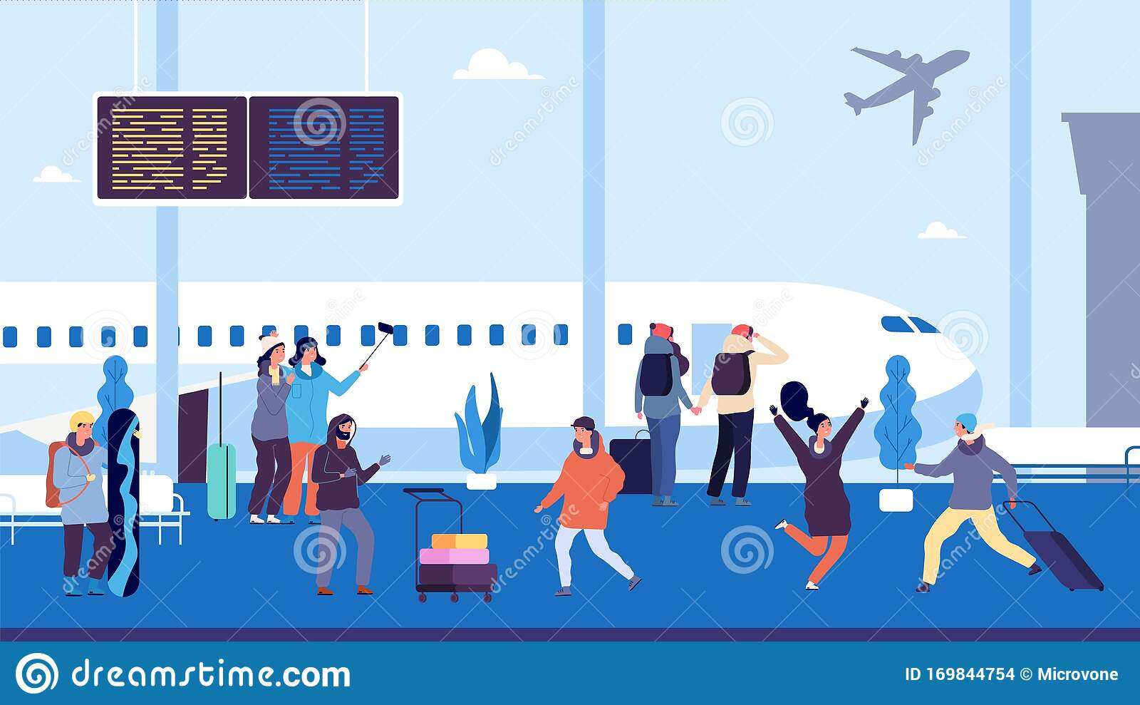 IN THE PICTURE:

**WHO:**

**WHAT:**

**WHEN**

**WHERE**

TITLE: ____________________________________

________________________________________________________________________________________________________________________________________________________________________________________________________________________________________________________________________________________________________________________________________________________

**WHY**

**HOW:**